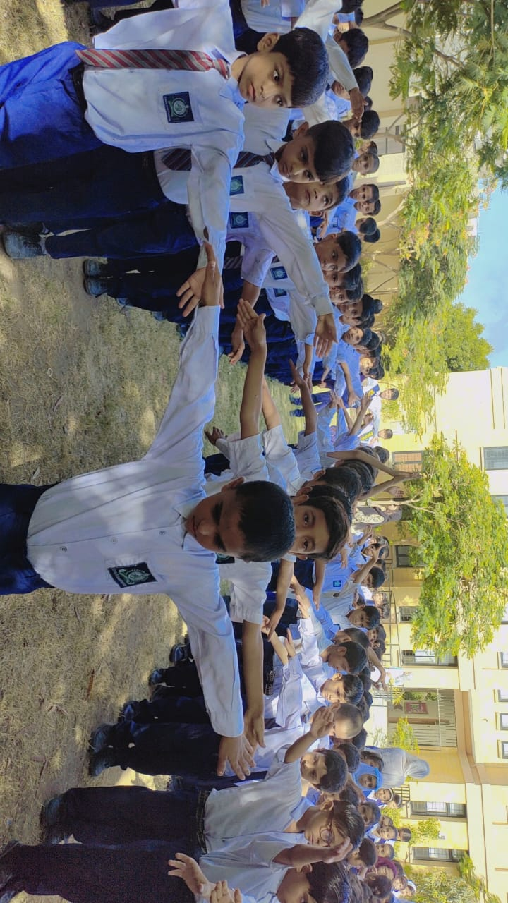
Fitness fun for our young stars!
Primary students showcasing their energy and teamwork during PT class.
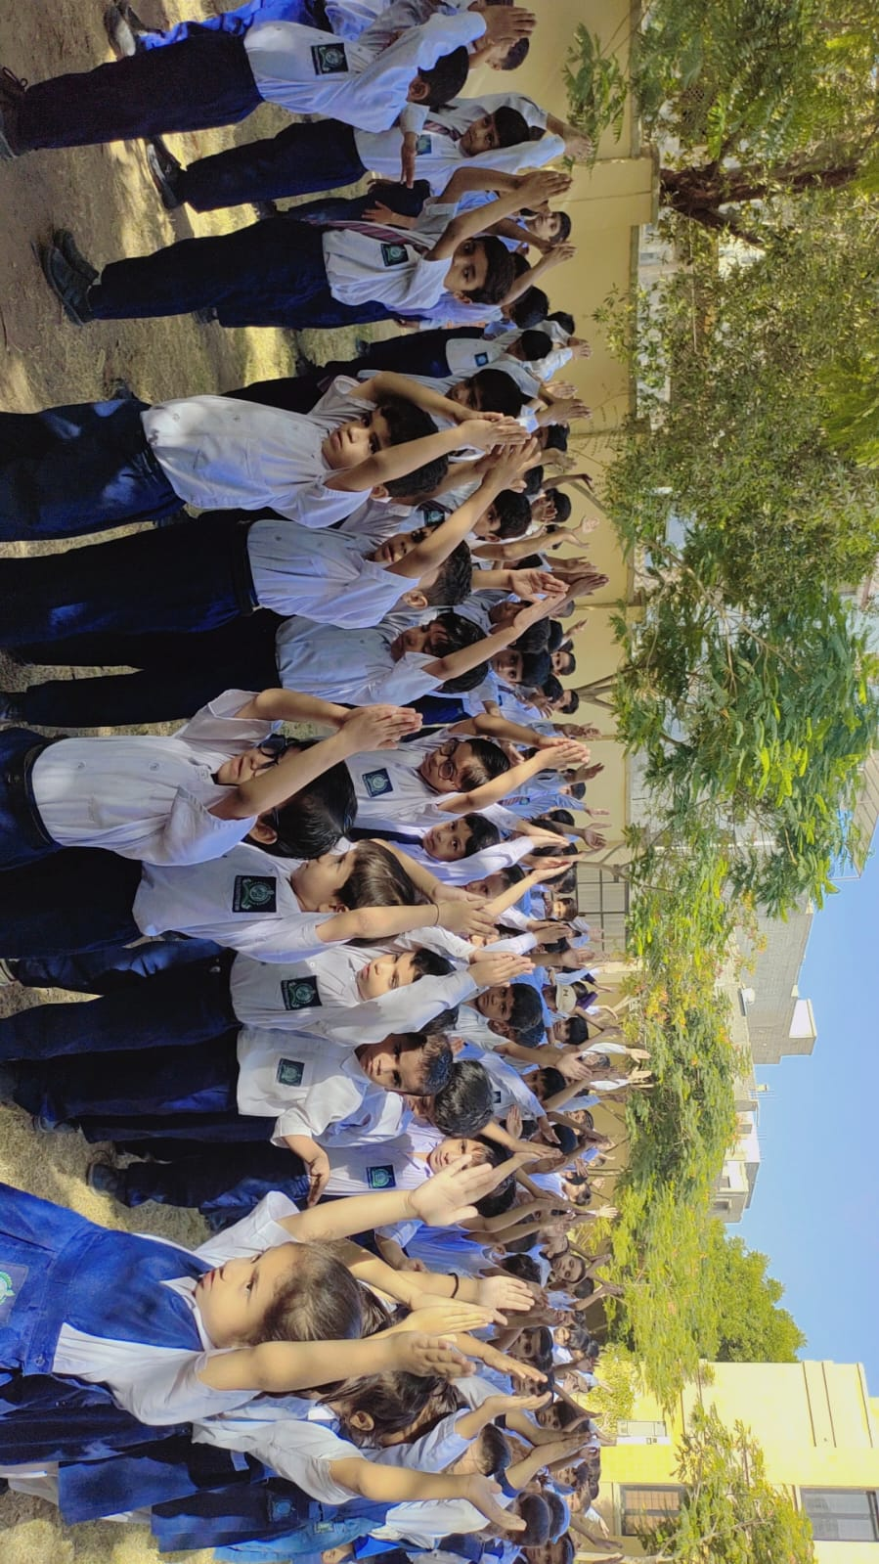
Promoting healthy habits from a young age.

